***FIRE ALERT SYSTEM***

**Prabhuram S S**

**Vignesh U K**

**Naveen R S**

**1st year ECE**

Abstract:

The main objective of this project is to develop a fire security system using an arduino board. as Technologies are emerging rapidly in the modern world, they must be utilized wisely to protect our surroundings from fire loss.

Block diagram: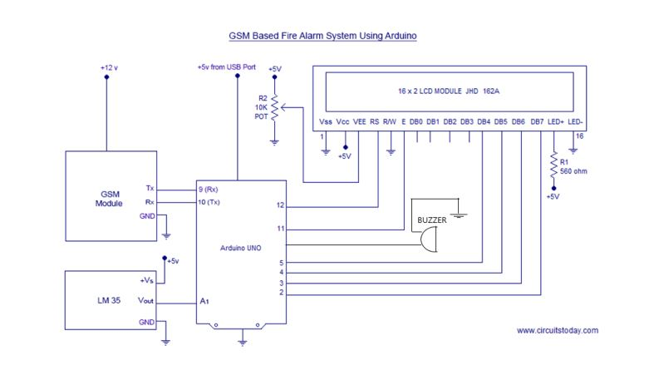

Conclusion:

Thus the fire security system has been designed and constructed successfully, and is also proved to work in the expected manner